**What’s cloud storage?**

Cloud storage provides a web service where your data can be stored, accessed and easily backed up by users over the internet

**Types of storage**

* S3, Cloud storage,
* Elastic Block Storage, EBS (SSD that gets attached to the VM)
* EFS Elastic File system, shared file system can be accessed from any point
* Glacier: archiving solution, Mass storage at low cost
* Storage Gateways: Moving data from local to cloud env.
* Snowball Edge: Data Import export system. in Hardware format
* Snowmobile: Very very large amount data transport.

Factors that make a repository expensive and time consuming are,

1. To Purchase Hardware and Software components
2. Hiring a team of experts for maintenance
3. Lack of Scalability based on the requirements
4. data Security requirements

**What is S3:**

Simple Storage Service (S3) provides object storage which is built for storing and recovering any amount of data anywhere over the internet.

Simple file storage where file size can reach as much as 5 TB and such any number of files can be stored.

It provides,

1. 99.99% durability and availability of objects.
2. Low cost,
3. Very scalable.
4. Security and Flexibility in terms of cost as well.
5. Simple Data Transfer

**Object storage service**: is storage service that can be accessed from internet and can only be used for data storage, in other words it cannot be used for installing any application or so.

An object consists of Data (file), key and metadata.

A bucket stores objects.

When data is added to a bucket, Amazon S3 creates a unique version ID and allocates it to the object. It gives a link url to access the data as well.

**Storage classes available in S3:**

* Standard for Frequent data access: suitable for use cases where latency should be low, (Frequently accessed data)
* Standard for infrequent data access: data is long lived, but less frequently accessed.
* Amazon Glacier: Data to be archived, where high performance is not a requirement and Low latency is not must to have.
* One Zone – IA storage class: Data is not accessed frequently and is stored in single availability zone.
* Amazon S3 Standard Reduced Redundancy Storage.: such data that is non critical and can be reproduced quickly in case of loss from other sources.

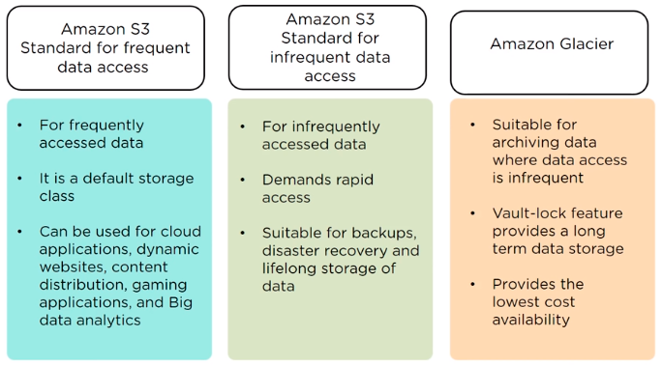

**Features:**

Data Lifecycle management, i.e.

1. Data transition from one type of storage class to other.
2. Auto expiration policy.

Bucket Access:

By writing a bucket policy file (JSON)

**Block storage:** cannot be accessed from internet as an application, but has to be attached to a virtual machine and then can be accessed for installing application or database storage etc.

Benefits of S3

Objects and Buckets

S3 features